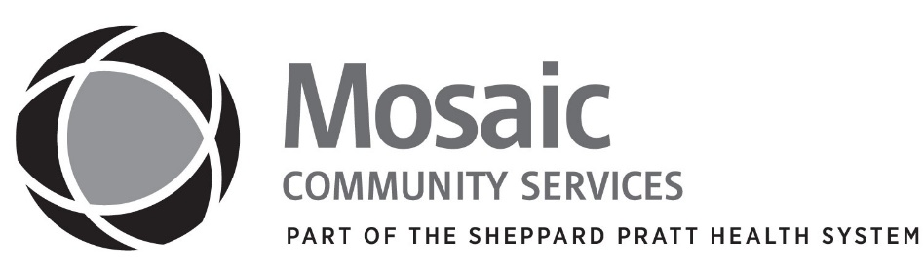

To Whom It May Concern,

Enclosed is the Mosaic Community Services, Inc. Financial Assistance Application. Please complete and return the application with appropriate attachments by January 31, 2020. DO NOT SEND ORIGINAL DOCUMENTS.

Your Financial Assistance Application will be reviewed and determination will be made within 30 days. Only completed Applications with appropriate attachments will be considered.

For your convenience, a return envelope is also included which has been pre-addressed to:

Mosaic Community Services

Attn: Billing Department

1925 Greenspring Drive

Timonium, MD 21093

Please feel free to call 410-453-9553 extension 3109 if you have questions or need additional information.

Thank you.

Sincerely,

Billing Department

Mosaic Community Services, Inc.

Enclosures